TASK 1

Basic Operations Of Power BI

Step 1: Launch Power BI and use the **Get Data** option located on the toolbar to import data from local storage.

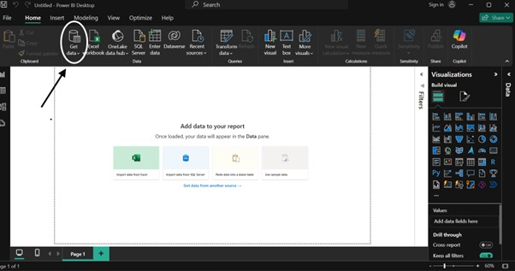

Step 2: After selecting **Get Data**, choose the **Text/CSV** option from the available data source formats to load the CSV file from your local storage.

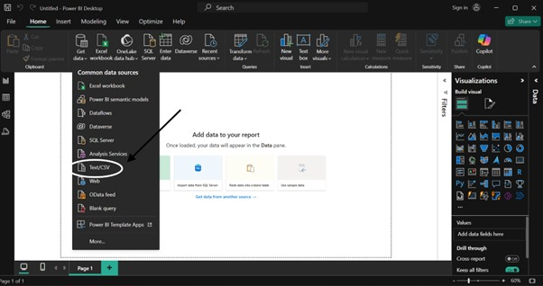

Step 3: Locate and select the required file from your local computer storage, then open it.

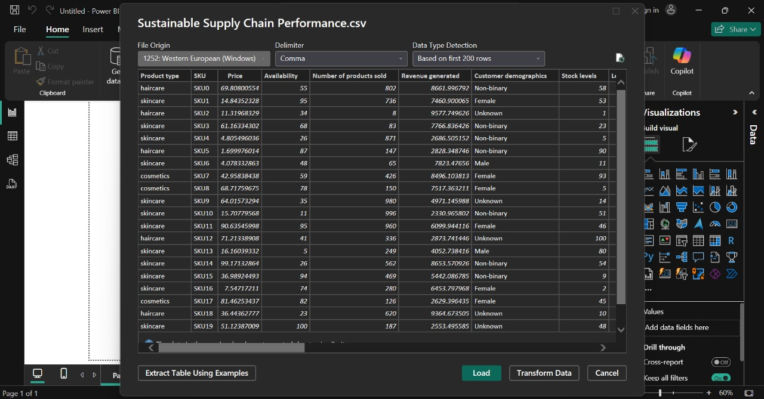

Step 4: Once the CSV file is loaded, click on the Transform Data option to clean and refine the dataset. This involves handling data issues like missing values or duplicates and removing unnecessary rows or columns to restructure the data.

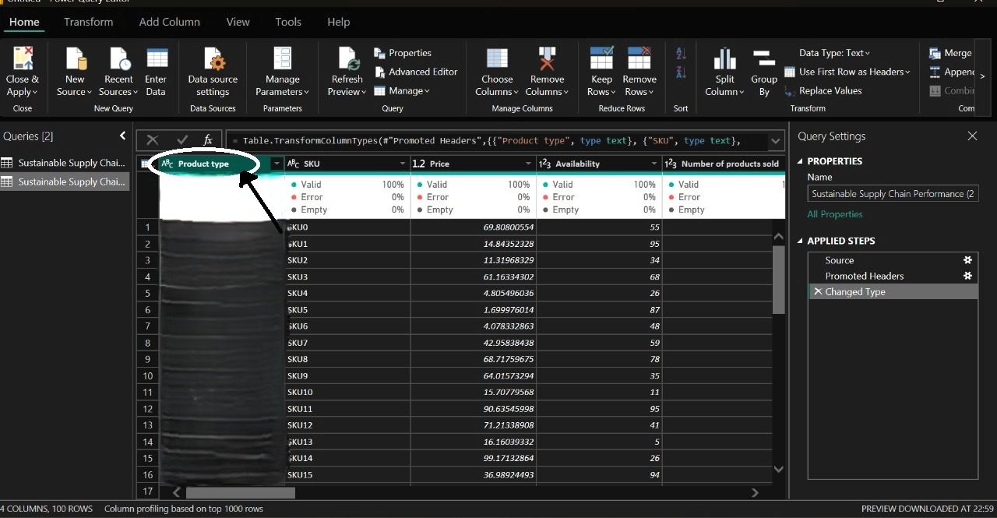

Step 5: To remove empty rows from the dataset, select the Remove Blank Rows option from the menu.

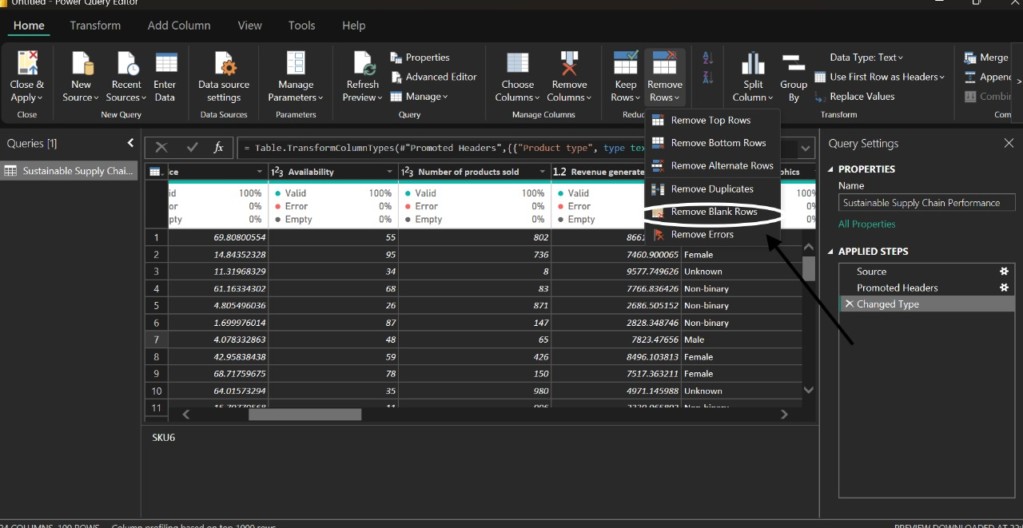

Step 6: To create more such tables right click on existing data on left side and select **DUPLICATE** option from there.

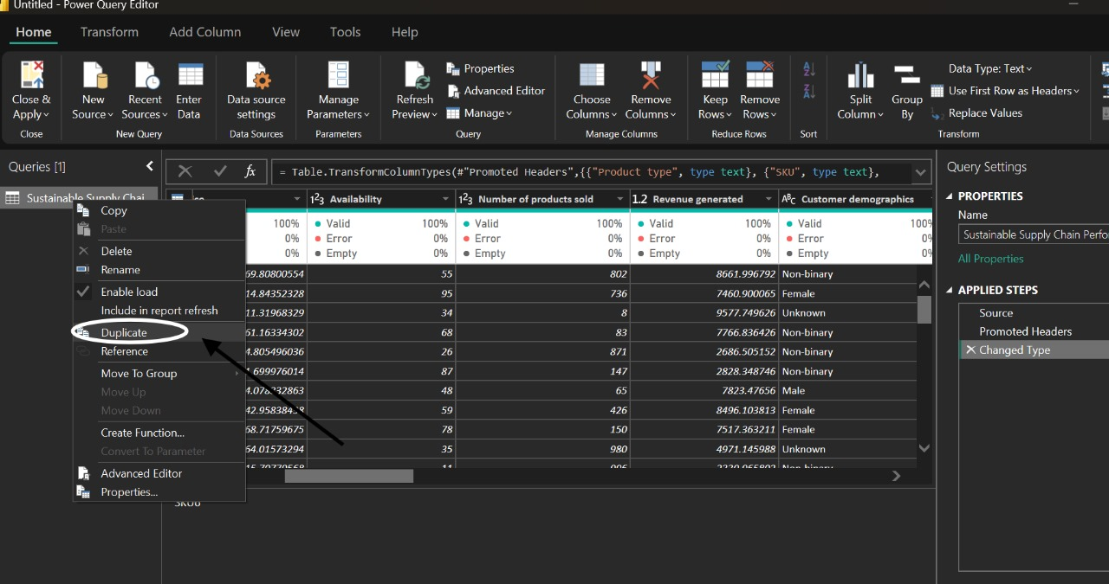

Step 7: Here are some tables which we can create by clicking on transform data and by selecting duplicate option.

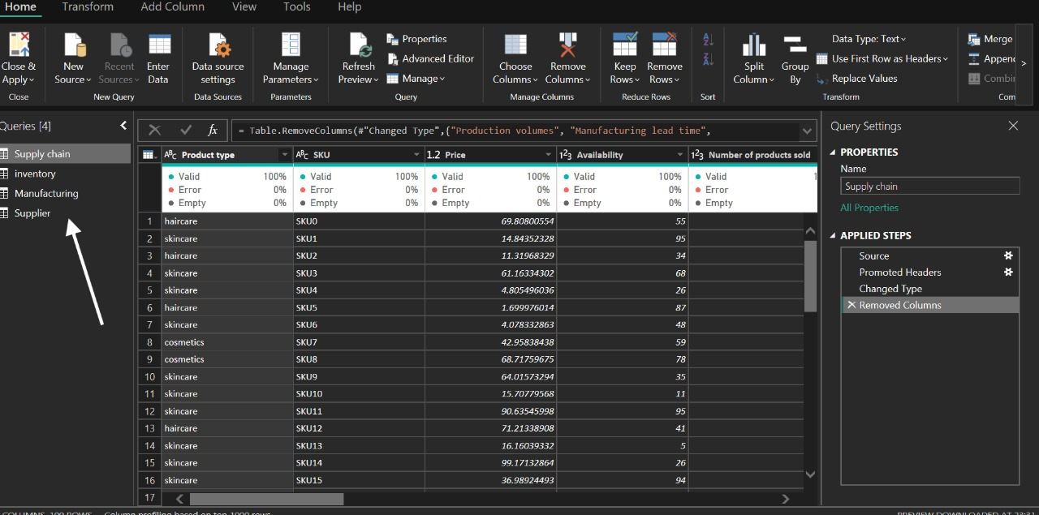

Step8: Once the data transformation task is done then click on the CLOSE AND APPLY button to load the data for further processing.

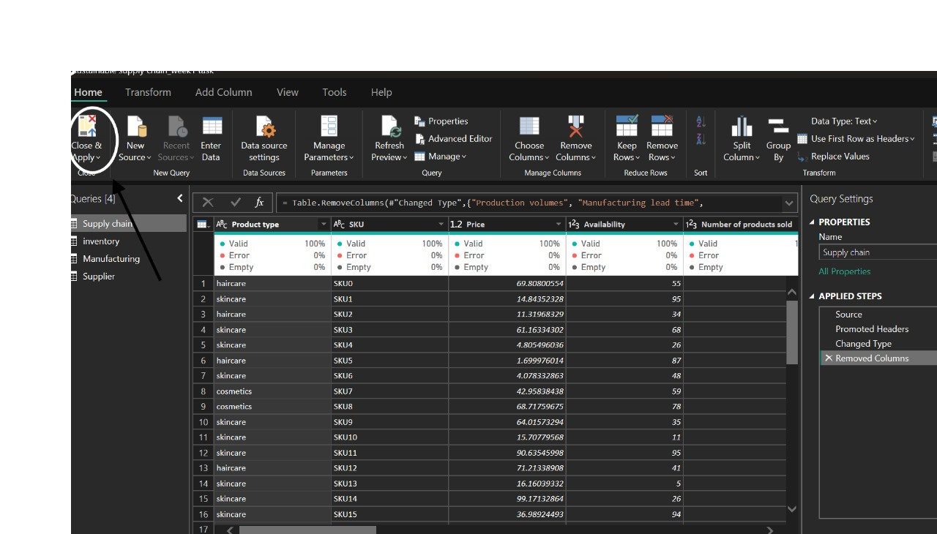

Step9: After loading the data go to the REPORT VIEW and visualize the dataset into desired format.

